

Exercises Report - Lab 3
LAB 3 -Testing SSH Security with Nmap and Hydra

Course: Cyber Security

Ljubljana, 26/5/2026 Vishnu Viswanath Thattrakkal
Student ID- 35250024

LAB 3 -Testing SSH Security with Nmap and Hydra

INTRODUCTION
In cybersecurity, attackers often begin by scanning systems to identify open ports and running services. This helps them find potential vulnerabilities and entry points into a target machine. Security professionals use the same techniques to test and improve system security.
In this exercise, two tools will be used: Nmap and Hydra. Nmap is used to scan a system and detect open ports and services, while Hydra is used to test the strength of SSH authentication through brute-force attacks. The exercise demonstrates how weak passwords and exposed services can create security risks and highlights the importance of securing SSH access and closing unused ports.

Preparation of the environment with Docker
The target system was prepared using Docker on the host computer. A Docker container containing a vulnerable SSH server was created and launched successfully. This environment was used as the target machine for testing network scanning and SSH brute-force attacks. Docker provides an isolated, controlled environment for running security tests without affecting the host operating system. After the container was started, the SSH service inside the container was verified to be running and accessible through the assigned network port.
The configured target system was then used throughout the exercise to perform port scanning with Nmap and authentication testing with Hydra.
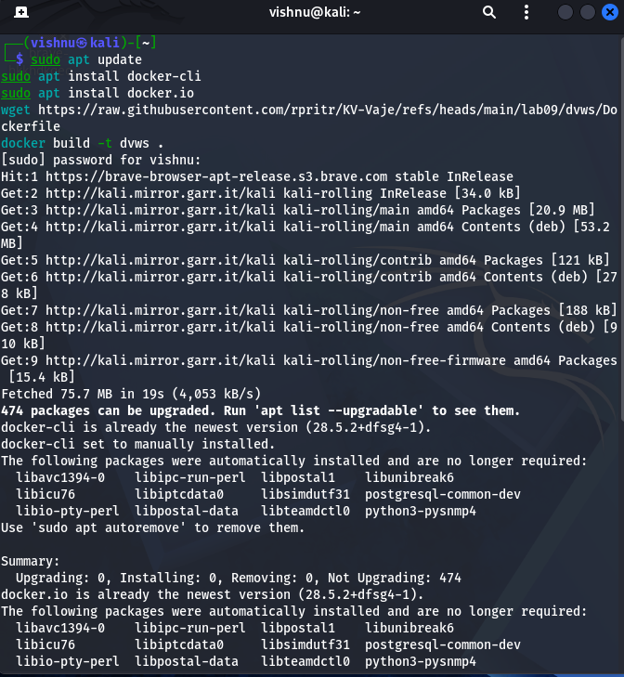
(Image 1)
After preparing the environment, the exercise started in the container
Sudo docker run -d -p 2222:22 --name dvws-ssh dvws.
The SSH server will now be available on the host computer at <target_ip>, port 2222, with user test user and password test123.

Testing SSH Security with Nmap and Hydra
SSH (Secure Shell) is used for secure remote access to systems. In this exercise, Nmap was used to scan open ports and services, while Hydra was used to test SSH password security through brute-force attacks. The exercise demonstrates the importance of strong passwords and securing unnecessary open services.
During this exercise, I analysed how Nmap can be used to detect open ports and running services on a target system. I also tested SSH password security using Hydra to understand how brute-force attacks work. The analysis demonstrated the security risks caused by weak passwords and unnecessarily open services on a system.
Step -1: scan for open ports with Nmap
First, check which services are available on the targeted system. For that, I used the local host for testing, which is 127.0.0.1
nmap -sS -sV -O -p- <172.17.0.2>
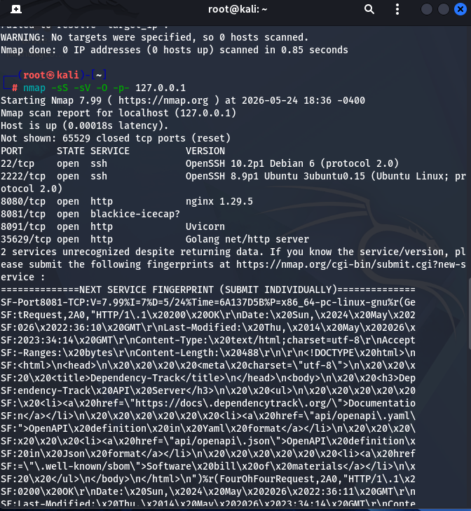
(Image -2)
- Which ports are open
as shown in image -2 there are 6 ports open
- 22/tcp
- 2222/tcp
- 8080/tcp
- 8081/tcp
- 8091/tcp
- 35629/tcp
- Which services are running
All of them are running as shown in the picture above.
- Open SHH
- Nginx
- HTTP services

- Which operating system version was detected
Debian and Ubuntu

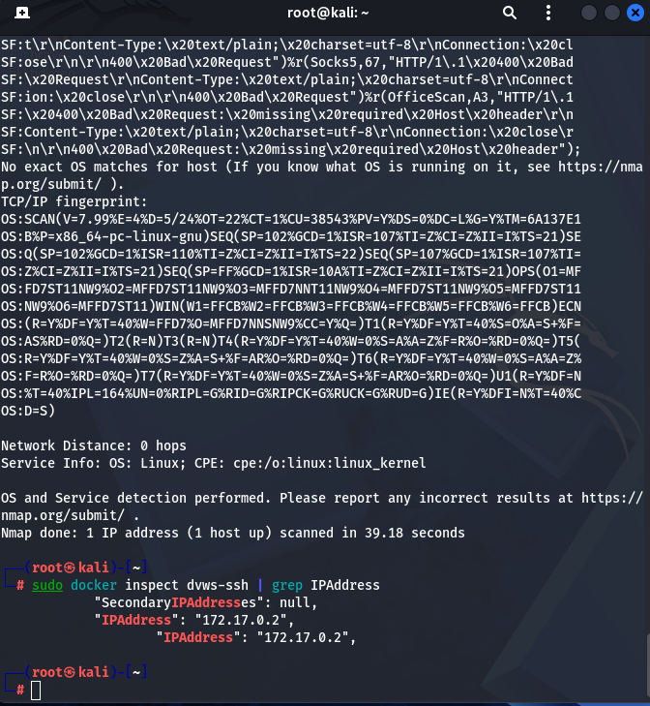
(Image -3 )
Using sudo docker inspect dvws-ssh l grep IP address, we can find the IP address of the server inside the Docker environment with the command.
Using this, we Nmap the address on IP address 172.17.0.2 as shown in image below (image -4)

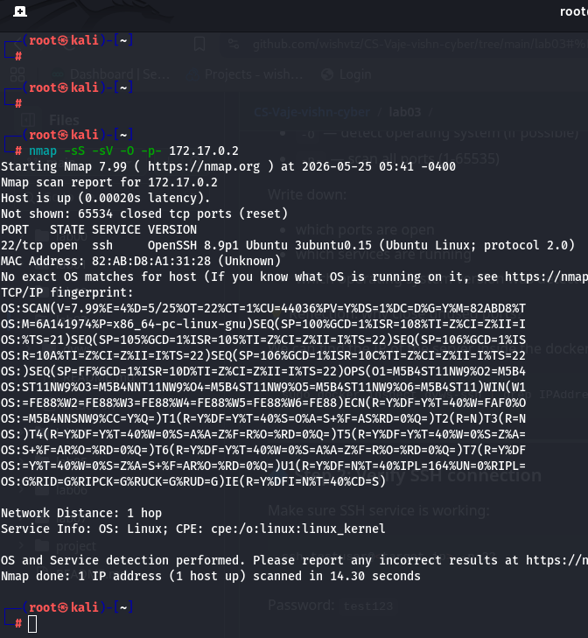
Image -4

Step 2: Verify SSH connection
Making sure SSH service is working
Running this script ssh testuser@ 172.17.0.2-p 22 and using password -test123
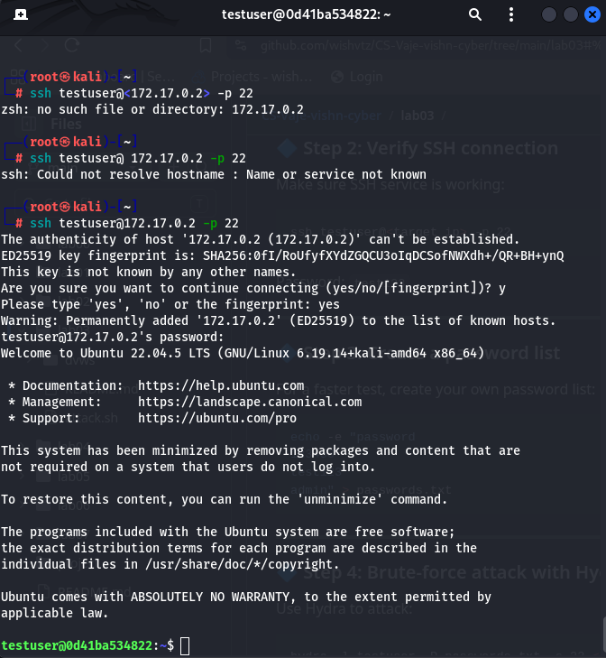
(Image -5)

Step 3: Create a password list
For a faster test, create your own password list:
echo -e "password
123456
test123
admin" > passwords.txt
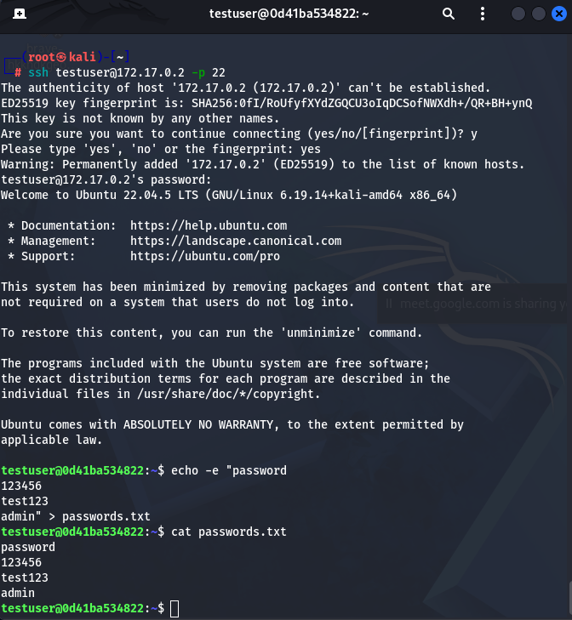
(Image -6)

Reflection and analysis
- How would you protect the SSH server from brute-force attacks?

Fail2Ban was used to block IP addresses after repeated failed login attempts automatically; password authentication was disabled and replaced with SSH key-based login; the default SSH port 22 was changed to another port to reduce automated attacks; and firewall rules were configured to allow SSH access only from trusted IP addresses.

- What additional measures (e.g. limits on the number of logins, use of public-private keys, firewall) would you recommend?

Root login over SSH was disabled, multi-factor authentication (TOTP/PAM) was enabled to add extra security, idle session timeouts were set to disconnect inactive sessions, an IDS like Wazuh was used to monitor suspicious login activity, and OpenSSH was kept updated with regular audits of open ports.
- How does the result change if we use a very strong password?
The wordlist attack fails immediately since a strong password won't appear in any dictionary. Exhaustive brute-force becomes practically impossible — a 16-character random password with mixed characters would take millions of years at typical attack speeds. The prolonged failed attempts would also be caught and blocked by fail2ban long before any success, making the attack both futile and self-defeating.

Step 4: Brute-force attack with Hydra
Hydra was used to perform a brute-force attack on the SSH service by testing multiple passwords from the `passwords.txt` file for the user `testuser`. The command targeted the SSH service running on port 22 of the target system to check whether weak passwords could be successfully identified.
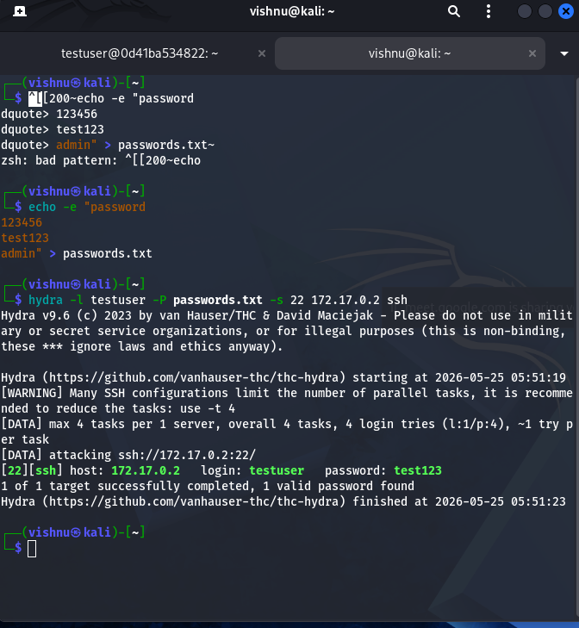
(Image-7)
The attack was successful, and Hydra identified valid login credentials. The output confirmed the correct password in the format:[22][ssh] host: <target_ip> login: testuser password: test123
This result demonstrated how weak passwords can be easily discovered through automated brute-force attacks, emphasizing the importance of strong authentication and secure SSH configurations.

